**Attack on Blob: Mega Multiply**

By: RenegadeWare

4.NBT.B.5

**What I Liked:**

* Quite liked that you had a functioning menu for Sound, and Music control. It can be a serious game-changer sometimes.
* The animated lessons of the LO were so well done, it actually made me see things differently!

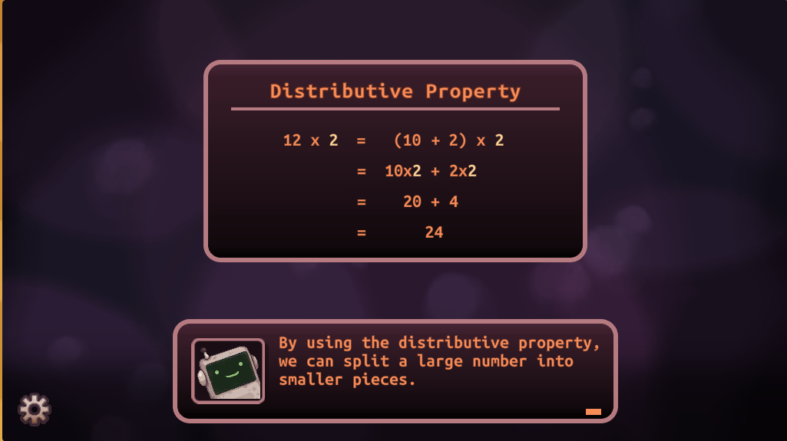

* Extremely polished UI and design, almost felt triple A!

**LO Issues:**

* I was finding this part to be very hard to understand. We went from a very well-taught mechanic to something very abrupt, and you did not give adequate teaching or visual instruction as you did before for me to understand how to get to the end result. I had to guess a bunch of times (especially since math is not my best subject) to hopefully get through this. I would definitely rethink your approach to this part, I know it’s kind of a bonus question but if I struggled, I'm sure many other students will as well. Maybe give the dual-layered equation in a box on the top left, to at least give some helpful visuals to get the answer.

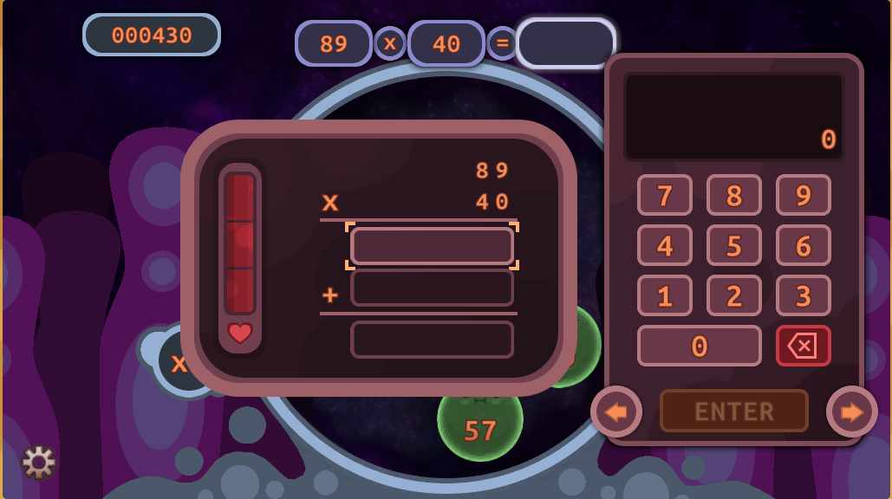

**Gameplay Issues:**

* I find that you can get to a point where if you just can't figure out an answer you are kind of stuck because there's no way to move on if you struggle with the calculations of some numbers. Is there a way after a couple of failures, you may help provide an answer just to make sure the student can get through the game?

You don’t need to do it right away, but maybe after 2 full failed attempts, you can help provide an answer for that level. And maybe give no points or something, just an idea.

I had to use a calculator for some parts, and I'm not sure if all students would have access to that, probably if they are on Chromebook they will.

[Can get stuck.mkv](https://drive.google.com/open?id=1dRieGHxem2sXhXIeIn_Zbc9MxB6EJVFQ&usp=drive_copy)

**Bugs:**

* I’m finding that if you are calculating a number above 1000 the end result will not show the proper numbers. It will shove the number above 1000 into the hundreds slot.

With more playthroughs, it looks like it's just the 1000s slot that is not working.

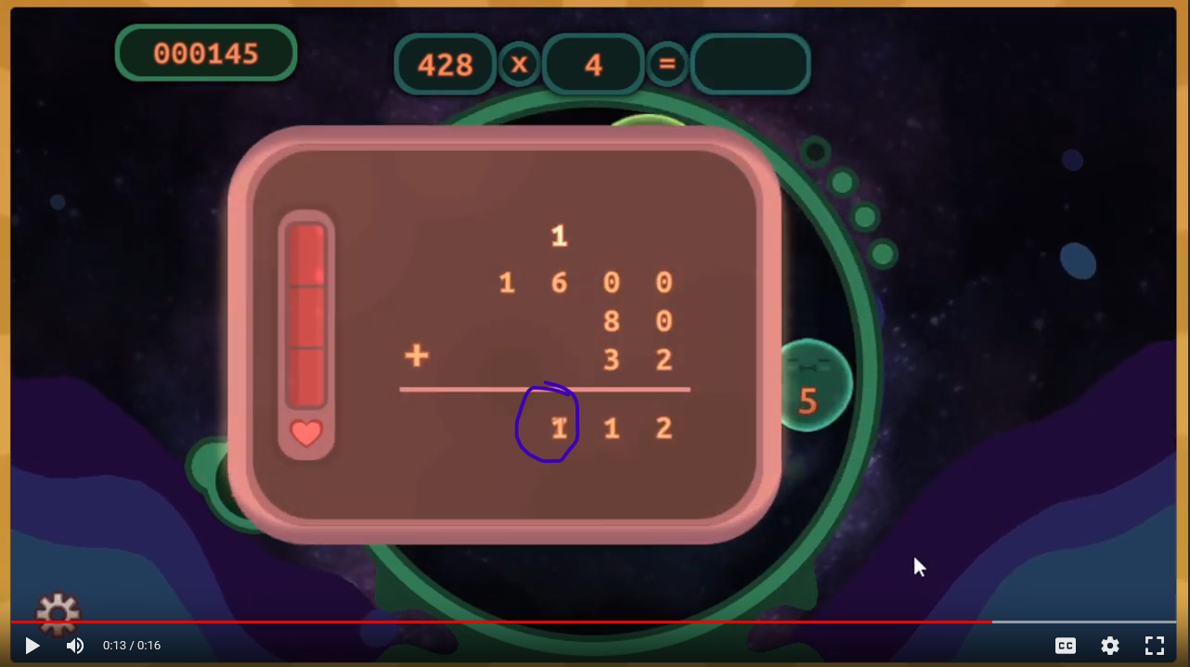

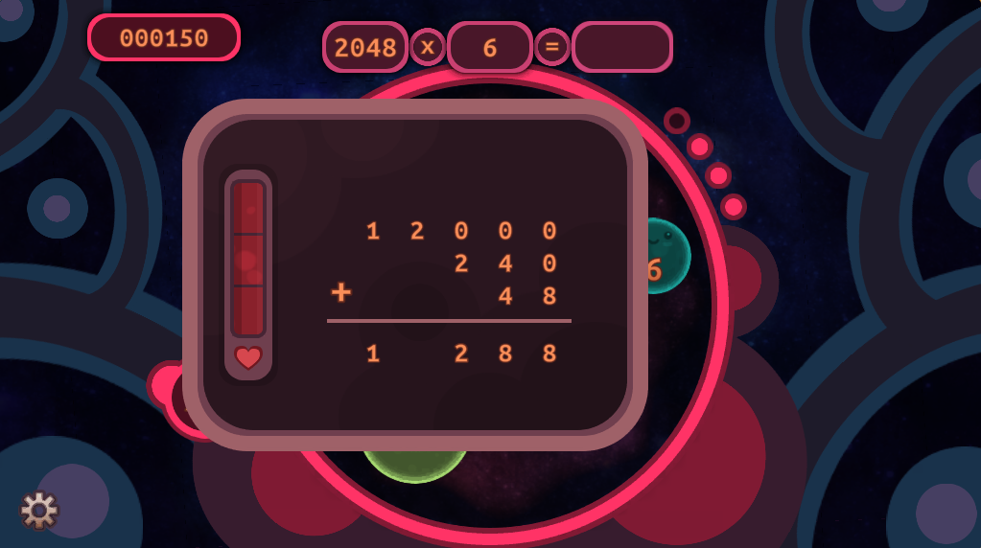

Numbers [above 100 won’t appear properly.mkv](https://drive.google.com/open?id=1LbokAmefnZ5MvaLuy2owKQzbsFGA1wfG&usp=drive_copy)

**Overall:**

I absolutely enjoyed this game, and even though I did find it stressful and difficult in some areas, I was able to get through it with ease, I should have posted my score so you can get a chuckle (had to whip out the calculator a couple of times). There was one part I found a little too difficult compared to the rest, but the teaching of the LO, and the gameplay itself were so well done, I am very impressed with what you have got here. Great job team!